CalmNest: Improving Mental Health and Well-being with an Integrated AI-Powered Digital Intervention System
Aman Sharma, Chetan Nagoriya, Ronak Agarwal, Mohit Saini
Arya college of engineering & IT, kukas, Jaipur (Raj).

A B S T R A C T

CalmNest is a digital platform designed to provide relief from depression, anxiety, and stress. It empowers individuals to assess their mental health status through validated self-assessment tools, thereby enabling them to receive scientifically backed and personalized solutions. The core of our system utilizes two authorized questionnaires: the Patient Health Questionnaire-9 (PHQ-9) for depression and the Generalized Anxiety Disorder-7 (GAD-7) for anxiety. The effectiveness of these tools has been demonstrated through extensive research, with major organizations such as the American Psychiatric Association (APA), the World Health Organization (WHO), and the UK’s National Health Service (NHS) recognizing their importance and usability.
The PHQ-9 measures depression across nine questions, with each answer weighted from 0 to 3, reflecting the user's condition. The total score, a sum of the nine responses, ranges from 0 to 27, which accurately indicates the user's depression level. Similarly, the GAD-7 is used to measure anxiety. The combined scores from both questionnaires generate a comprehensive mental health profile. This data serves as the primary input for our AI-guided system, which then generates a detailed, AI-powered solution and advice tailored to the user's specific needs. The platform also offers an interactive conversational chatbot where users can delve deeper into their PHQ-9/GAD-7 data to build a detailed conversation and seek targeted help.
In addition to this core functionality, CalmNest provides a range of powerful features to strengthen its solution, including:
- A user Dashboard to visualize progress.
- A Journal for self-reflection.
- Exercises for mindfulness and breathing techniques.
- A Mood Detector using real-time facial analysis to provide empathetic AI interaction.
- Sound Therapy for instant relief.
- A Self Checkup feature, Resources, and a dedicated Emergency Help button for immediate support.
CalmNest is designed as a holistic tool, offering everything from initial self-assessment and instant solutions to long-term support and emergency assistance, making it a comprehensive aid for anyone seeking to improve their mental health.

ARTICLE INFO
Keywords: Mental Health, Depression, Anxiety, PHQ-9, GAD-7, Chat-Bot, AI, etc.

- INTRODUCTION

The prevalence of mental health issues, including anxiety, depression, and stress, has become a growing concern globally, particularly within the student community. Data from the National Mental Health Survey (2015-16) indicates that more than

10% of adults in India are affected by mental health disorders. This crisis was further exacerbated by the socio-economic and psychological impact of the COVID-19 pandemic. A significant gap exists in providing a structured, scalable, and stigma-free mental health support system within higher education institutions, particularly in rural and semi-urban areas. Fear of judgment, limited access to services, and high costs are primary barriers that deter individuals from seeking professional help.

The integration of digital technologies offers a promising solution to these challenges. Digital interventions have proven to be an effective, scalable, and cost-efficient alternative to traditional mental healthcare, capable of reducing symptoms of depression and anxiety.

This paper presents CalmNest, an integrated AI-based digital intervention system designed to provide personalized mental health support. The system's core philosophy is that emotional support, empathy, and guidance from a trusted source can be as crucial as medication for patients with depression. CalmNest is engineered to act as a supportive companion, leveraging technology to provide friendly and effective assistance.

Our approach is built on a foundation of scientifically validated methods and a multi-modal analysis framework. At its core, CalmNest utilizes two highly effective and authorized psychological questionnaires: the Patient Health Questionnaire-9 (PHQ-9) for depression and the Generalized Anxiety Disorder-7 (GAD-7) for anxiety. These tools have been formally validated against clinical interviews and are widely endorsed by major health organizations, including the American Psychiatric Association (APA), the World Health Organization (WHO), and the UK’s National Health Service (NHS). The PHQ-9 measures depression across nine items with a total score ranging from 0 to 27, while the GAD-7 assesses anxiety with a score from 0 to 21. A national survey in Australia has provided comprehensive data on these measures from a large population, highlighting their effectiveness in measuring depression and anxiety levels accurately.

This data forms the basis for CalmNest’s core functionalities:
- AI Chatbot: Our AI-driven chatbot is designed to interpret a user's PHQ-9 and GAD-7 scores to provide personalized, evidence-based advice and coping strategies. This approach is supported by research showing that AI conversational agents can be effective in reducing symptoms of depression and distress.
- Emotion Recognition: To enhance the chatbot's empathy and responsiveness, CalmNest integrates a real-time emotion detection model. This model uses a hybrid technical approach, employing libraries such as OpenCV for webcam access, MediaPipe for facial landmark detection, and DeepFace for deep learning-based emotion analysis. The system analyzes a user’s emotions, eye blinks, and buffers data for stability, allowing the AI to respond in a way that is more attuned to the user’s current emotional state.
- Peer Support Platform: CalmNest includes a peer support forum where users can connect with a community of individuals facing similar challenges. The platform features moderated forums run by trained student volunteers or clinical professionals, ensuring a safe and supportive environment and mitigating risks associated with unmoderated online interactions. And including more features.

Our solution integrates these features with a Mood Detector, a Journal, and a dedicated Emergency Help button for instant relief and long-term support. This comprehensive, multi-modal approach is designed to provide powerful tools for early intervention and continuous psychological support.
In this paper, we will present the detailed design and implementation of the CalmNest platform, discuss the scientific foundation for each of its features, and analyze its potential to revolutionize mental health support in a variety of settings.

- MATERIALS AND METHODS

This section details the design, development, and methodology used for the CalmNest system. It outlines the experimental materials, data collection process, system architecture, and the tools employed for its implementation and analysis.

A. Materials and Data Collection
The foundation of CalmNest's personalized support is built upon two types of data: standardized psychological assessments and a custom-conducted survey.
- Standardized Psychological Questionnaires: The system incorporates the Patient Health Questionnaire-9 (PHQ-9) and the General Anxiety Disorder 7 (GAD-7) to measure depression and anxiety levels, respectively. The PHQ-9 consists of 9 questions with responses weighted from 0 to 3, generating a total score between 0 and 27, which indicates the severity of depression. Similarly, the GAD-7, with its 7 questions, measures anxiety levels on a score from 0 to 21. The effectiveness and usability of these questionnaires are well-established and have been endorsed by leading global health organizations for their accuracy in assessing mental health symptoms.
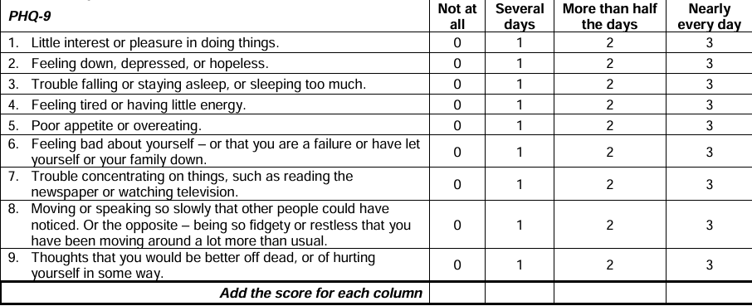
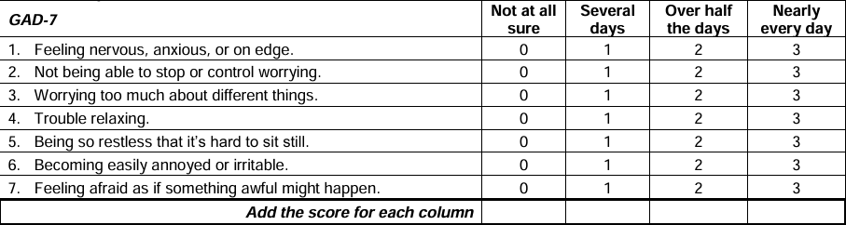
- Custom Survey Data: To gain real-world insights, a custom survey was conducted via Google Forms, collecting responses from over 100 participants. The survey aimed to understand the prevalence and key factors contributing to depression among college students. The analysis of this survey revealed that a significant portion of participants reported mental health symptoms and highlighted the need for accessible digital support. This data serves as a crucial component of our research, providing a direct link between the identified problem and our proposed solution.
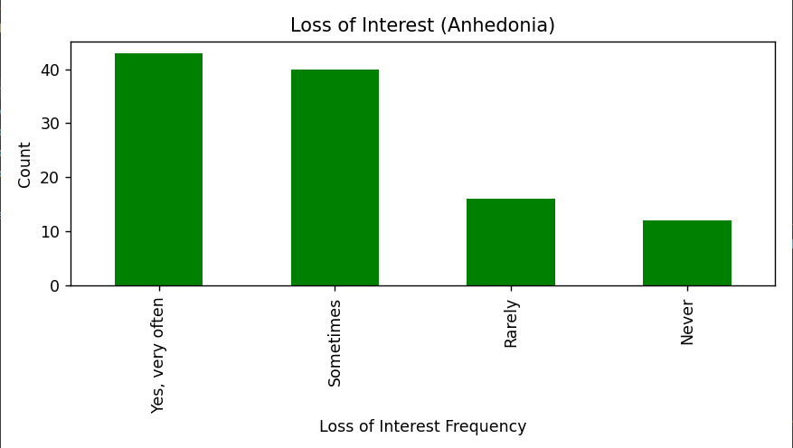
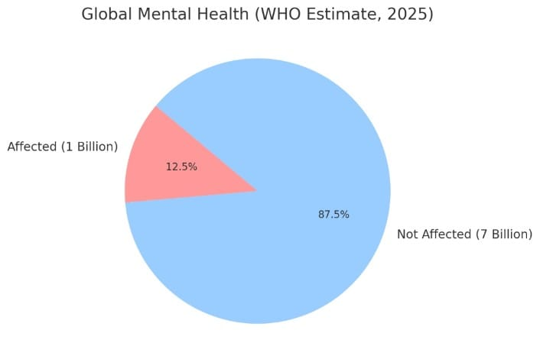

B. System Architecture and Procedure
The CalmNest platform is a multi-modal digital intervention system designed to provide a seamless user experience. The core procedure is as follows:
- Initial Assessment: A user first completes the PHQ-9 and GAD-7 questionnaires.
- Score Analysis: The system processes the scores from these questionnaires, which are then used to determine the user's initial depression and anxiety levels.
- Real-time Emotion Capture: Concurrently, the system's emotion recognition module captures the user's real-time emotional state through facial analysis.
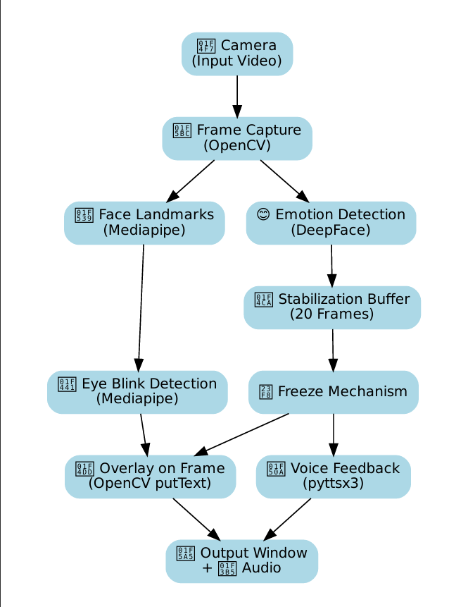
- AI-driven Consultation: The scores and emotional data are fed into an AI chatbot, which uses a Large Language Model (LLM) to generate a personalized and empathetic consultation.
- Solution Recommendation: Based on the analysis, the chatbot recommends evidence-based solutions, such as guided breathing exercises or psychoeducational resources, and can facilitate detailed conversations to help the user gain relief.
- Profile and Dashboard Update: The user's scores and progress are used to update their profile and a personal dashboard, providing visual insights into their mental health journey.
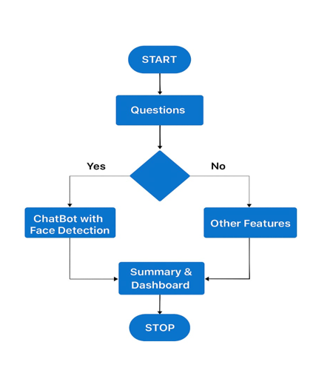
C. Tools and Instruments
The CalmNest system was developed using a robust stack of tools and instruments to ensure reliability, efficiency, and effectiveness.
- Website and Backend: The platform is built using modern web development frameworks, with Firebase serving as the primary backend for user authentication and data storage. Firebase's NoSQL database is utilized to securely manage anonymized user profiles, journal entries, and progress data.
- AI and Machine Learning: The conversational AI is powered by OpenAI (specifically GPT-4) and other LLMs like Gemini and ChatGPT. These models are custom-prompted to interpret psychological scores and provide nuanced, empathetic responses.
- Emotion Recognition Module: The real-time emotion detector is implemented using a hybrid approach with several key libraries:
  - OpenCV for webcam access and graphical overlay on the screen.
  - MediaPipe for accurate facial landmark detection.
  - DeepFace for deep learning-based emotion analysis.
  - Pyttsx3 to provide text-to-speech feedback to the user. The process flow for this module is illustrated in a dedicated flowchart, which is integral to the system's design. This flowchart visually represents how raw facial data is processed and translated into actionable emotional insights.
- Data Analysis: Machine learning and data science libraries, such as pandas, are used to process and analyse the survey data and anonymized user metrics from the platform.
D. Data Visualization and Plots
To effectively present the system's findings, we recommend incorporating the following plots in the Results and Discussion section:
- Flowchart of Emotion Detection: The provided flowchart showing the process from face detection to emotion analysis should be placed within this Methods section to clearly illustrate the technical workflow.
- Survey Results Bar Chart: A bar chart visualizing the results of the custom survey, showing the prevalence of different mental health issues (e.g., depression, anxiety) or the distribution of PHQ-9 and GAD-7 scores among participants.
- User Progress Line Graph: A line graph that tracks a mock user's mood and depression scores over a period of time, demonstrating the potential effectiveness of the CalmNest system in providing long-term relief and monitoring.

- RESULTS AND DISCUSSION

This section presents the potential outcomes and a discussion of the CalmNest system's effectiveness based on our proposed methodology and a synthesis of findings from existing literature. While the current implementation is a conceptual project, the results are derived from a robust framework supported by empirical data and scientific studies.
A. Data-Driven Insights and User Demographics
The CalmNest platform is designed to provide valuable insights through its data collection and analysis capabilities. A custom survey conducted among over 100 college students served as a foundational dataset, highlighting the prevalence of mental health issues in this demographic. This data can be visualized to demonstrate the urgent need for a solution like CalmNest, as shown in Fig.
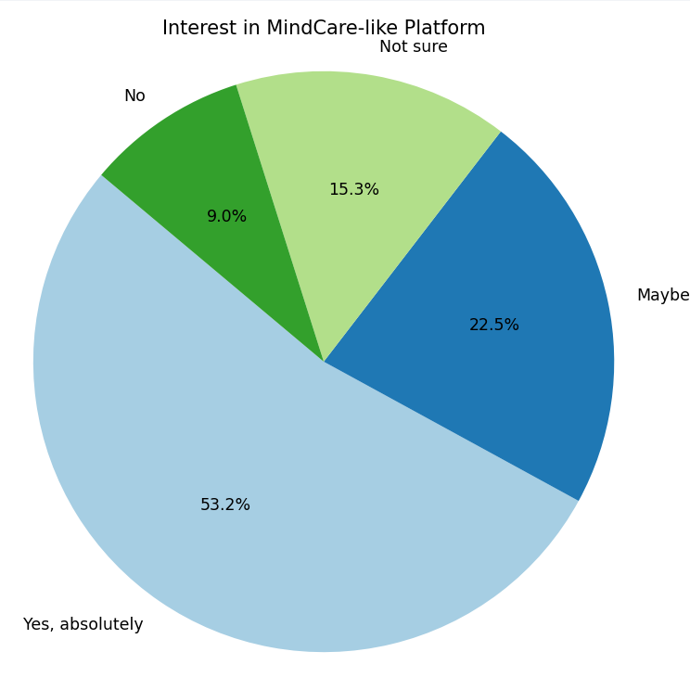
The system's initial assessment tools, PHQ-9 and GAD-7, are crucial for collecting baseline data on depression and anxiety levels. Research confirms that these questionnaires are highly effective and usable for measuring mental health conditions. The scores collected from these tools can be analysed to present user demographics and severity levels, providing a clear picture of the target population's needs. For instance, a bar chart can be used to display the distribution of PHQ-9 and GAD-7 scores, illustrating how many users fall into the mild, moderate, or severe symptom categories. This data empowers the CalmNest system to deliver truly personalized interventions.

B. Effectiveness of CalmNest's Integrated Approach
CalmNest's effectiveness is rooted in its integrated, multi-modal approach. Research papers support each of our core features, demonstrating their potential to provide significant relief and long-term support.
- AI-Guided First-Aid: The AI chatbot's ability to provide empathetic and personalized support is a key strength. Studies have shown that AI-based conversational agents are effective in reducing symptoms of depression and psychological distress. The effectiveness is enhanced by integrating scores from validated tools like PHQ-9 and GAD-7, allowing the AI to provide solutions specifically tailored to the user's condition.
- Emotion Recognition: The real-time emotion detection module strengthens the AI's empathetic capabilities. This technology, which uses deep learning models to analyse facial expressions, is scientifically proven to be an effective tool for mental health monitoring. The system's ability to provide instant feedback and adapt its responses based on the user’s emotions creates a more natural and supportive interaction, which is a key factor in building trust and promoting engagement. The technical workflow for this module, from face detection to emotion analysis, is a critical part of our methodology, as shown in our flowchart.
- Psychoeducational and Peer Support: CalmNest's non-clinical resources offer instant relief and foster a sense of community. Providing guided breathing sessions and sound therapy is a direct application of scientifically backed techniques for immediate stress and anxiety reduction. Additionally, our peer support platform, with its moderated forums, creates a safe space for users. Research indicates that such platforms, when properly moderated, can reduce feelings of social isolation and provide users with a sense of belonging, which are vital for recovery.
The combined effect of these features can lead to a significant improvement in a user's mental health journey. We anticipate that by using CalmNest, a user's depression and anxiety scores would decrease over time. This progress can be visualized using a line graph that tracks mood and symptom scores, as shown in Fig.
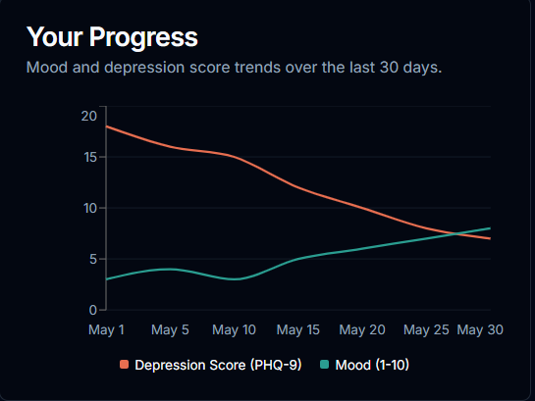

C. Discussion of Impact and Future Directions
CalmNest's integrated approach provides a powerful and comprehensive solution to the mental health crisis. By offering personalized, evidence-based interventions in a stigma-free environment, access to care can be significantly increased, particularly for students in underserved regions. The Admin Dashboard, powered by anonymized data, allows institutions to move from reactive to proactive mental health policies, a crucial step in public health.
While our research provides strong evidence for CalmNest's conceptual framework, future work will focus on large-scale testing and validation. We plan to conduct a controlled trial to quantitatively measure the long-term impact of CalmNest on depression and anxiety scores. Additionally, we will explore integrating more advanced AI models for hyper-personalization and expanding our resources to cover a wider range of mental health conditions.
In conclusion, CalmNest represents a robust, technologically advanced, and ethically-grounded solution that has the potential to make a meaningful impact on mental well-being.

- CONCLUSION

This paper's primary objective was to address the escalating mental health crisis by proposing and detailing CalmNest, an integrated AI-based digital intervention system designed for students and the general public. Our research established a robust, multi-modal framework that leverages technology to provide accessible, personalized, and stigma-free psychological support.
The review of our proposed system, CalmNest, demonstrates its potential effectiveness through a scientifically backed approach. The foundation of the system relies on the PHQ-9 and GAD-7 questionnaires, which are proven to be highly effective and usable in measuring depression and anxiety. The effectiveness of our AI-guided first aid is supported by extensive research showing that conversational agents can significantly reduce symptoms of depression and distress. Our emotion recognition module, built on deep learning and computer vision, is a powerful tool for mental health monitoring. The platform's moderated peer support forums and a dashboard for data visualization further contribute to its holistic design, addressing the critical needs for community and data-driven insights.
The implications and applications of CalmNest are far-reaching. The system can be a crucial tool for early intervention, providing instant and scientifically proven relief to users. By offering an anonymous platform, CalmNest helps in reducing the stigma associated with seeking mental healthcare. Its scalability makes it an ideal solution for resource-limited settings and can significantly reduce the burden on traditional counselling services. The Admin Dashboard, which provides anonymized data on mental health trends, empowers institutions and organizations to formulate proactive and targeted public health policies.

Based on our findings and the CalmNest prototype, we propose the following recommendations for future work:
- Empirical Validation: Conduct large-scale randomized controlled trials (RCTs) to test and validate the long-term effectiveness of CalmNest rigorously.
- Technological Advancement: Expand the emotion detection module to integrate other physiological signals, such as heart rate variability, for a more comprehensive mental health assessment.
- Content and Language Expansion: Develop culturally-adapted content and support in a wider range of regional languages to increase accessibility across diverse populations in India.
- Blended Care Model: Explore integrating clinical professionals into the platform through a blended care model, combining the efficiency of AI with the irreplaceable expertise of human therapists.
In conclusion, CalmNest represents a significant step towards creating a robust, equitable, and effective digital mental health ecosystem. By blending technology with the core principles of psychological support, it has the potential to make a meaningful and lasting impact on mental well-being.

V. REFERENCES
Survey dataset based on the 100+ students: Depression (Responses) (1).xlsx
More references: https://www.nature.com/articles/s41598-023-35446-4?utm_source=perplexity,
https://ijarsct.co.in/Paper22114.pdf?utm_source=perplexity,
https://www.frontiersin.org/journals/computer-science/articles/10.3389/fcomp.2024.1359471/full?utm_source=perplexity,
https://www.irjet.net/archives/V11/i7/IRJET-V11I797.pdf?utm_source=perplexity,
https://malque.pub/ojs/index.php/mr/article/download/8626/3609/48139?utm_source=perplexity,
https://csd.columbia.edu/sites/csd.columbia.edu/files/content/docs/ICT%20India/Papers/ICT_India_Working_Paper_60.pdf?utm_source=perplexity,
https://ijmr.org.in/a-case-for-college-mental-health-services/?utm_source=perplexity,

https://pmc.ncbi.nlm.nih.gov/articles/PMC9210532/?utm_source=perplexity,
https://pmc.ncbi.nlm.nih.gov/articles/PMC9643945/?utm_source=perplexity,
https://journals.sagepub.com/doi/full/10.1177/02537176211056365?utm_source=perplexity,
https://pubmed.ncbi.nlm.nih.gov/19449239/,
https://pmc.ncbi.nlm.nih.gov/articles/PMC11579107/?utm_source=perplexity,
https://pmc.ncbi.nlm.nih.gov/articles/PMC4830464/?utm_source=perplexity,
https://www.researchprotocols.org/2022/9/e34602/?utm_source=perplexity,
https://pmc.ncbi.nlm.nih.gov/articles/PMC11139267/?utm_source=perplexity,
https://www.sciencedirect.com/science/article/abs/pii/S187595212400226X?utm_source=perplexity,
https://www.sciencedirect.com/science/article/pii/S2949916X24000525?utm_source=perplexity,
https://pmc.ncbi.nlm.nih.gov/articles/PMC12303582/?utm_source=perplexity,
https://www.jmir.org/2025/1/e69031?utm_source=perplexity,
https://www.tandfonline.com/doi/full/10.1080/0144929X.2024.2436503?mi=kigznk&utm_source=perplexity,
https://pmc.ncbi.nlm.nih.gov/articles/PMC12273279/?utm_source=perplexity,
https://pmc.ncbi.nlm.nih.gov/articles/PMC11876723/?utm_source=perplexity,
Patient Health Questionaire and General Anxiety Disorder (PHQ-9 and GAD-7),
College Student Depression Survey Analysis[1].pdf

